**Practice: Fill in the blanks**

**Part 1**

**Use collocations to complete these sentences**:

|  |
| --- |
| Make calls give presentation send text access the internet    do research transfer money store information |

1. Thanks to Wi-Fi, it’s now easy to ………………………………from cafes, hotels, parks and many other public places.
2. Online banking lets you …………………….between your accounts easily and securely.
3. *Skype* is a technology that enable users to ………………………... over the Internet for free.
4. In many universities, students are encouraged to …………………….. using PowerPoint in order to make their talks more visually attractive.
5. The Web has revolutionized the way people ……………………….. – with sites such as *Google* and *Wikipedia*, you can find the information you need in seconds.
6. Cookies allow a website to ……………………….... on a user’s machine and later retrieve it; when you visit the website again, it remembers your preferences.
7. With the latest mobile phones, you can ………………...… with multimedia attachments – pictures, audio, even video.

**Part 2**

|  |
| --- |
| **update, planning , calculate, make, row, transforms, cell , commands** |

Ok, everyone. Let’s begin with the basics. A spreadsheet program is normally used in business for financial(1)……………………– to keep a record of accounts, to analyze budgets or to (2) ……………… specific calculations. It’s like a large piece of paper divided into columns and rows. Each column is labelled with a letter and each(3)…………….. is labelled with a number. The point where a column and a row intersect is called a (4)………….. For example, you can have cells A1, B6, C5 and so on.

A cell can hold three types of information: text, numbers and formulae.

Formulae are functions or operations that add, subtract, multiply or divide existing values to produce new values. We can use them to (5)………………….totals, percentages or discounts.

When you change the value of one cell, the values in other cells are automatically recalculated. You can also (6)……………….. the information in different worksheets by linking cells. This means that when you make a change in one worksheet, the same change is made in the other worksheet.

The format menu is a spreadsheet usually includes several (7)…………. ……….allowing you to choose the font, number alignment, borders, column width, and so on.

Most spreadsheet programs can also generate graphic representations. The value of cells are shown in different ways, such as line graphs, bar or pie charts. There are even three-dimensional options.

Some spreadsheet programs also have a database facility which (8)……………………….the values of the cells into a database. In this case, each column is a field and each row is a record

**Part 3**

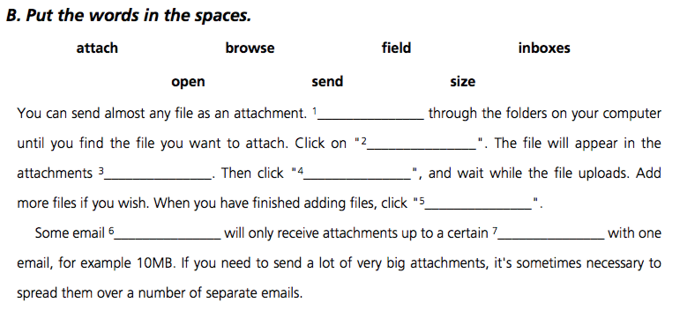

**Part 4**

|  |
| --- |
| DAW CD ripper hypermedia sound card video coputing  MIDI webcast streaming audio techcology |

1. The power of multimedia software resides in hypertext, ……………….. and interactivity.
2. As long as your computer has a……………….., you can use it to capture sounds in digital format and play them back.
3. Sound cards offer two capabilities: a built-in stereo synthesizer and a system called ……………………..which allows electronic musical instruments to communicate with computers
4. A…………………………………………(DAW)lets you mix and record several tracks of digital audio.
5. ……………….………is a program that extracts music tracks and saves them on disks as MP3s
6. ……………………..…………………………….lets you listen to the audio in a continuous streams while it is being transmitted.
7. The broadcast of an event over the web is called a………………………….
8. ……..………………………refers to recording, manipulating and storing video in digital format.

**Part 5**

**Complete the letter with *suitable words***

|  |
| --- |
| On in (2) for (4) since ago until where been start |

Dear Mr Mikkola,

I am writing to apply (1)_____a job of graphic designer, which was advertised (2)____ your company website.  
I have a bachelor’s degree (3)________graphic design from Koln Technical College, Germany. I started to work in the DTP field six years (4)_____, when I attended an in-company training course in Helsinki as part of the Leonardo Da Vinci Program. The project was coordinated by Heltech College, and I did practical training in Lonberg P.O, a Finnish company specializing (5)_____ printing advertising material.

Before taking my present job, I worked for two years with KBI, a German publishing company,(6)________I used Adobe Illustrator, Photoshop and Quark Express to layout books and magazines. I stayed in this job (7)_____ June 2004.

(8) _______ the last three years I have been working part-time at VEM Verlag, where I’ve been responsible(9)_______graphic design and digital imaging. (10)_____ February this year I have (11)_____using Adobe InDesign, the new standard in professional page layout. I have knowledge of mainstream computer platforms, including Macintosh and Windows.

I would welcome the opportunity to work for your company. I would like to improve my graphic and typographic design skills and eventually more into management.

Please find enclosed my CV along with samples of my work. I will be available (12)______ an interview at any time. The earliest date that I could (13)_____ work is 21 May.

**Part 6: put the verbs into the correct forms**

*Complete these texts with the passive form of the verbs in brackets.*

The Phonograph (*invent*) _______________ by Thomas Edison in 1877, who discovered how to record music and voice on a metal cylinder of tin foil.

Magnetic tapes (*manufacture*)_______________by German audio engineers at AEG and Bash in the 1930s, and the first compact disc (*design*)___________ by Philips and Sony in 1980. Three years later, CDs reached the market in Asia and the US. In the near future, CDs, (*probably replace*) ___________________ by new technologies such as DVD-Audio, HD-DVD and Blu-ray discs.

The most recent development in digital recording has been the MP3 format, which has generated the market for portable Mp3 players and iPods. Today, more than 50% of all music (*buy*)_________________ online and many music tracks (*download*) ____________________ illegally.

**Part 7**

**The telephone**

Alexander Graham Bell is remembered today as the inventor of the telephone in 1876. A year later, his invention (*improve*)___________ by Thomas Edison, by adding a microphone.

The first fully automatic mobile phone (*introduce*) _____________ by Motorola in 1981. Nowadays, new mobile phones (*develop*)_________________, with emphasis on multimedia, radio and real-time TV. Some models (*call*)__________ smartphones.

**Part 8**

**The computer**

The first computers built using silicon chips went on sale in 1965. Microsoft (*found*) ____________by Bill Gates and Paul Allen in 1975 to sell a version of the BASIC language for the Altair computer. The first IBM-PC (*sell*) ____________ in 1981, becoming a standard for personal computers.

Every year, more and more people get on the Internet. Today, the Web (*can access*) ____________ from PDAs, mobile phones – indeed, from anywhere at any time. In the future, artificial intelligence and voice recognition (*incorporate*) _____________ into most computer applications.

Part 9;

**Complete these sentences with words from the box**

|  |  |  |  |
| --- | --- | --- | --- |
| Raster graphics | Wireframe | Filters | Toolbox |
| Vector graphics | Rendering | Primitives |  |

1. Graphics programs have a ______ that enables you to draw, paint and edit images on the computer.
2. Bitmaps, or _____, are stored as a series of tiny dots called pixels.
3. ______ are created using mathematical formulas describing shapes, lines and curves. They are used by drawing programs to create images that can be scaled without loss of quality.
4. The basic elements used to construct graphical objects are called______; they include lines, circles, polygons and text.
5. CAD designers often start a project by making a ____, a drawing showing the edges and vertices of a 3-D model.
6. ______ is the technique used to make a graphic object look realistic, by adding reflection, shadows and highlights.
7. In image-editing programs, _____ are special effects that can be applied to pictures.